TCN4211
Telecommunication Networks

Lab Number 1
Title: Lab 1 - Learn to Use Packet Tracer

Author Name: Anaisy Garcia PID: 5734454

Due: Sep 13



Florida International University

OBJECTIVES:
The main purpose of this experiment is to become familiar with Cisco Packet Tracer. Other objectives include creating a model of an Ethernet network containing two hosts and a hub, observing traffic behavior of ICMP packets on a network, and observing ARP tables and ping within the desktop of the hosts.

EQUIPMENT and COMPONENTS USED
For this lab the equipment used was:
- Laptop
- Cisco Packet Tracer Program
  - Within the Cisco Program, the components used were two generic pcs and a hub connected with copper straight-through cables.

EXPERIMENTAL METHOD AND PROCEDURE
Procedure:
- Set up network of two generic PCs and a hub by connecting with copper straight-through cables.
- Rename host names using PC config and establish IP address with a subnet mask.
- Send an ARP packet containing ICMPs then observe the network traffic.
- Open command prompt on both desktops and type “arp -a” to see the ARP table.

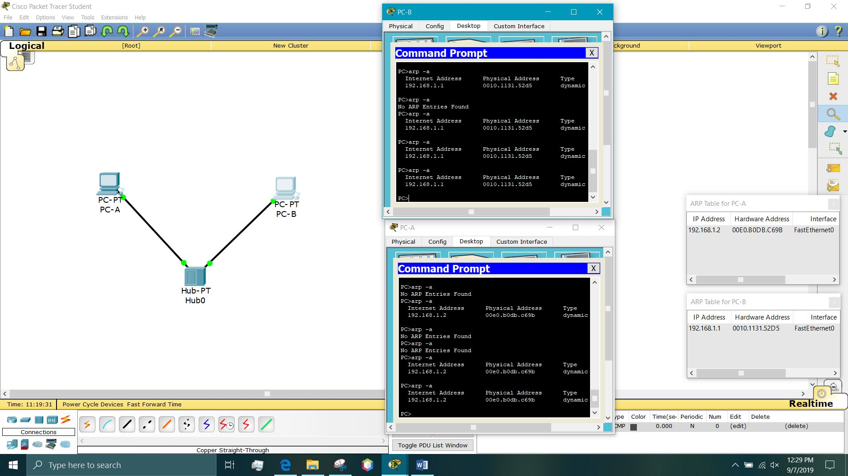
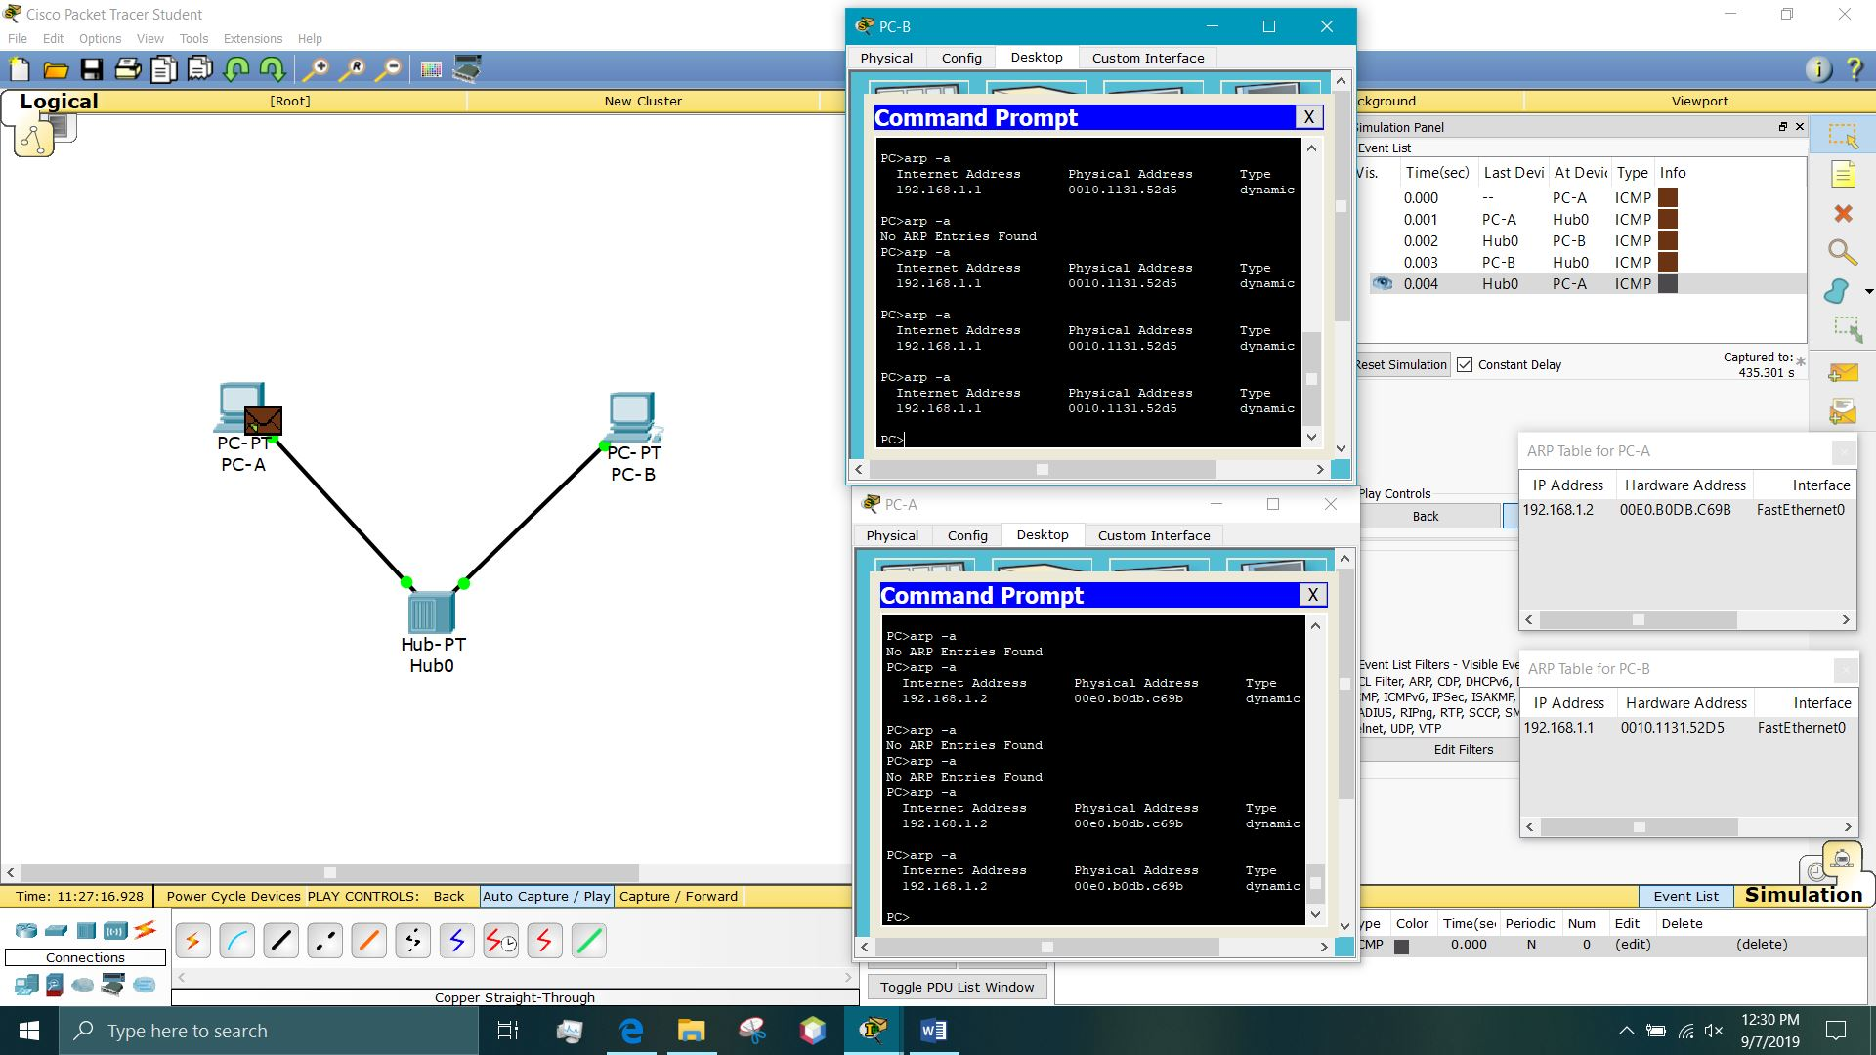

RECOMMENDATIONS and CONCLUSIONS

The lab consisted of a very limited but important number of findings such as how to connect computers to a hub and send information to and from as well as small things that are important such as setting up IPs and understanding that sending packages at the same time from different computers would destroy the data. This lab was important to establish the base for later labs.

